# To Do List - Android

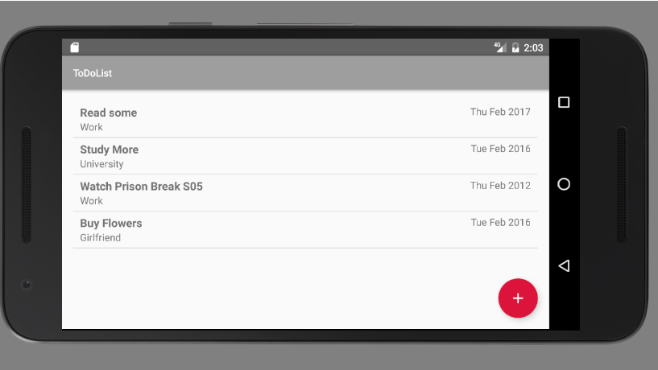

Build **RESTful** Web Services with **Spring Boot**. Create an **oversimplified** mobile application that consumes **JSON** via **Android**.

## Download Android Studio

In case you haven’t done it yet you can get it from [here](https://developer.android.com/studio/index.html).

## Create New Project

Create a new project:

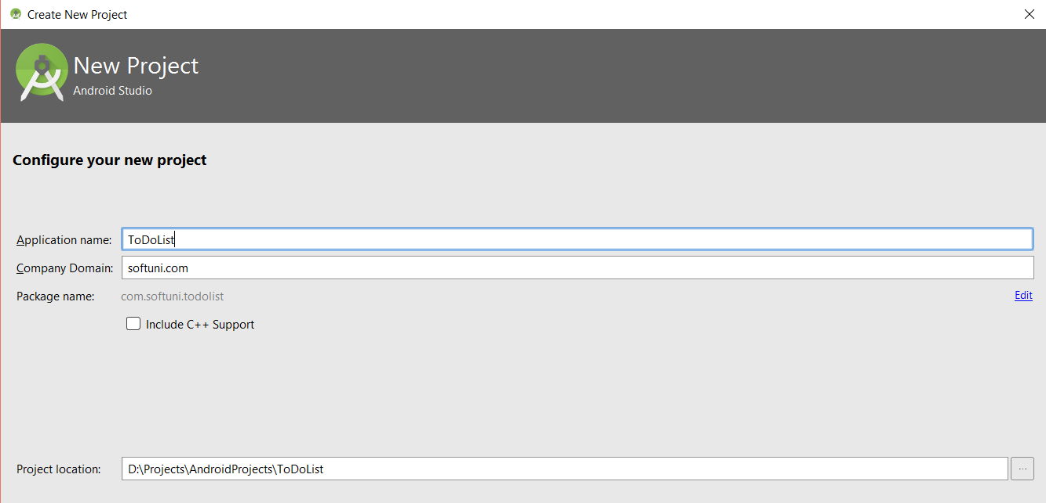

Choose Jelly Bean API as a minimal **API** version which will be **supported** by your **application**.

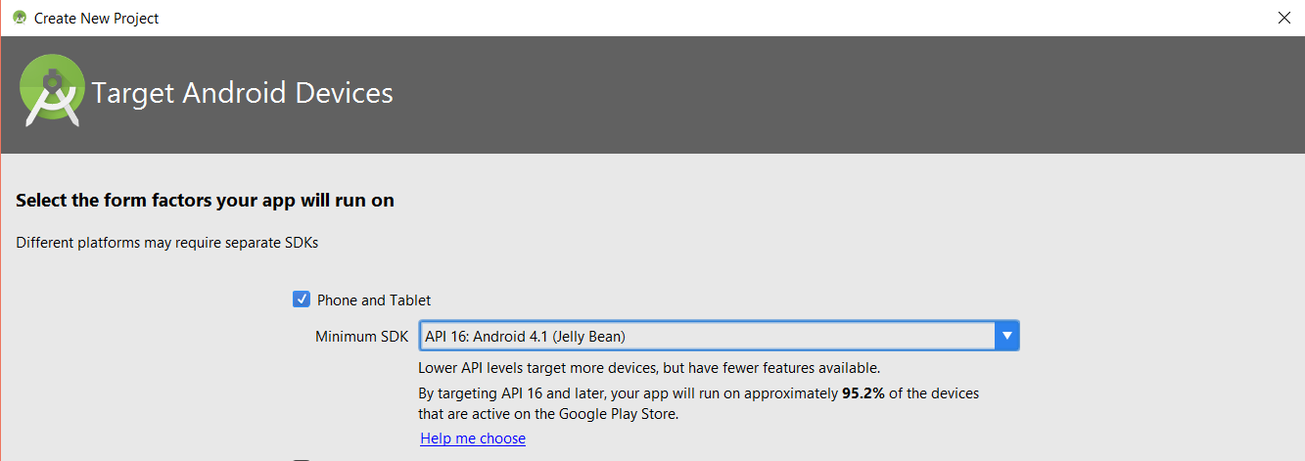

Choose **Basic Activity**.

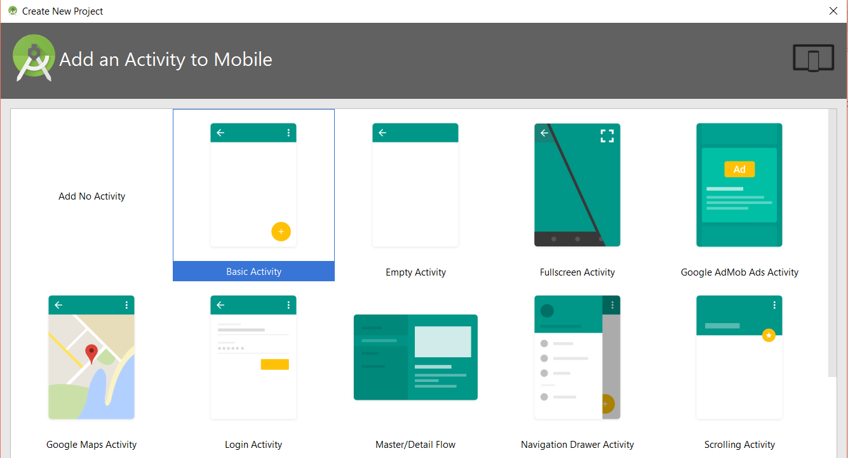

Create a single **Activity**. You can read more about activities [here](https://developer.android.com/reference/android/app/Activity.html).

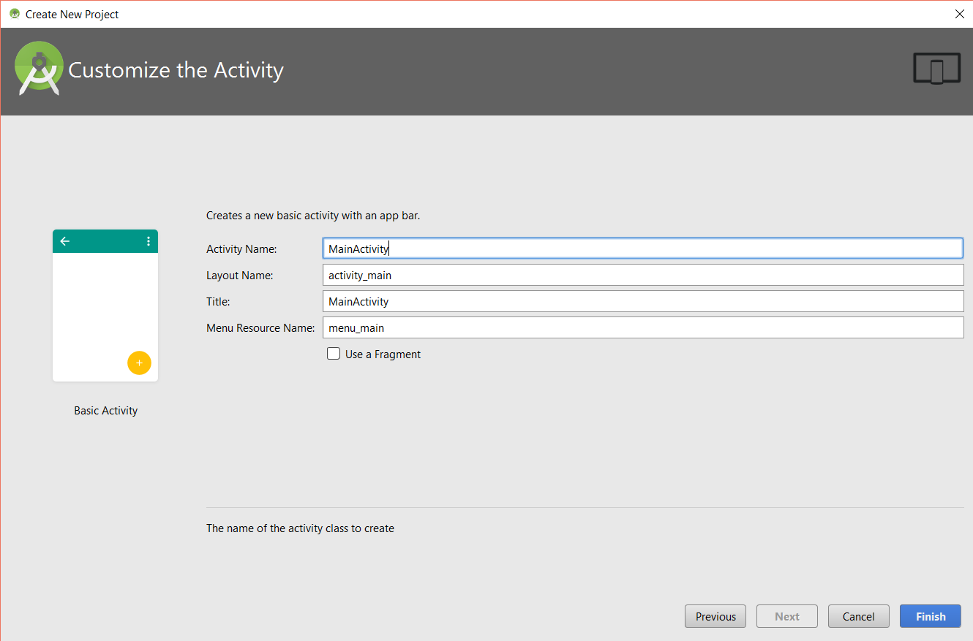

## Final Project Structure

Here is the final project **structure**.

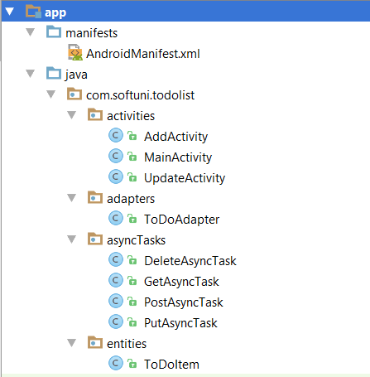

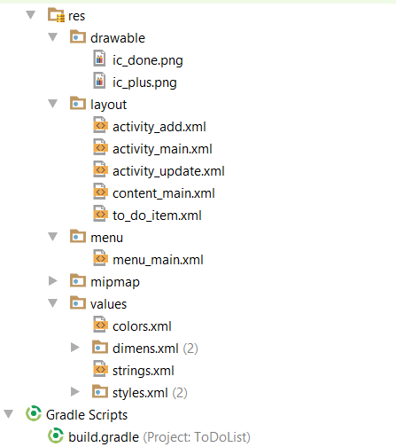

## Create ToDoItemEntity

Create a single entity for our data.

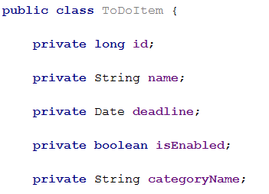

Make your To Do Item [Parcelable](https://developer.android.com/reference/android/os/Parcelable.html):

|  |
| --- |
| **ToDoItem.java** |
| **package** com.softuni.todolist.entities;   **import** android.os.Parcel; **import** android.os.Parcelable; **import** android.text.format.DateFormat;  **import** java.util.Date;  **public class** ToDoItem **implements** Parcelable {   **private long id**;   **private** String **name**;   **private** Date **deadline**;   **private boolean isEnabled**;   **private** String **categoryName**;   **public long** getId() {  **return this**.**id**;  }   **public void** setId(**long** id) {  **this**.**id** = id;  }   **public** String getName() {  **return this**.**name**;  }   **public void** setName(String name) {  **this**.**name** = name;  }   **public** Date getDeadline() {  **return this**.**deadline**;  }   **public void** setDeadline(Date deadline) {  **this**.**deadline** = deadline;  }   **public boolean** isEnabled() {  **return this**.**isEnabled**;  }   **public void** setEnabled(**boolean** enabled) {  **isEnabled** = enabled;  }   **public** String getCategoryName() {  **return this**.**categoryName**;  }   **public void** setCategoryName(String categoryName) {  **this**.**categoryName** = categoryName;  }   **public** ToDoItem() {  }   **protected** ToDoItem(Parcel in) {  **id** = in.readLong();  **name** = in.readString();  **long** tmpDeadline = in.readLong();  **deadline** = tmpDeadline != -1 ? **new** Date(tmpDeadline) : **null**;  **isEnabled** = in.readByte() != 0x00;  **categoryName** = in.readString();  }   @Override  **public int** describeContents() {  **return** 0;  }   @Override  **public void** writeToParcel(Parcel dest, **int** flags) {  dest.writeLong(**id**);  dest.writeString(**name**);  dest.writeLong(**deadline** != **null** ? **deadline**.getTime() : -1L);  dest.writeByte((**byte**) (**isEnabled** ? 0x01 : 0x00));  dest.writeString(**categoryName**);  }   @SuppressWarnings(**"unused"**)  **public static final** Parcelable.Creator<ToDoItem> ***CREATOR*** = **new** Parcelable.Creator<ToDoItem>() {  @Override  **public** ToDoItem createFromParcel(Parcel in) {  **return new** ToDoItem(in);  }   @Override  **public** ToDoItem[] newArray(**int** size) {  **return new** ToDoItem[size];  }  }; } |

## Dependencies

Add dependency for [Recycler View](https://developer.android.com/reference/android/support/v7/widget/RecyclerView.html) and GSON.

|  |
| --- |
| **build.gradle** |
| dependencies {  …compile **'com.android.support:recyclerview-v7:25.0.+'** compile **'com.google.code.gson:gson:2.2.4'** compile **'com.googlecode.json-simple:json-simple:1.1'** } |

## Icons

Add two custom icons to for the UI. You can choose on your own from [here](https://icons8.com/web-app/for/androidL/add).

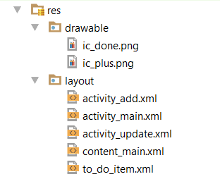

## Layouts

Layouts are the equivalents of views. You need 4 [views](https://developer.android.com/reference/android/view/View.html):



1. Activity_main – Contains the main application

|  |
| --- |
| **activity_main.xml** |
| *<?***xml version="1.0" encoding="utf-8"***?>* <**android.support.design.widget.CoordinatorLayout xmlns:android="http://schemas.android.com/apk/res/android"  xmlns:app="http://schemas.android.com/apk/res-auto"  xmlns:tools="http://schemas.android.com/tools"  android:layout_width="match_parent"  android:layout_height="match_parent"  android:fitsSystemWindows="true"  tools:context="com.softuni.todolist.activities.MainActivity"**>   <**android.support.design.widget.AppBarLayout  android:layout_width="match_parent"  android:layout_height="wrap_content"  android:theme="@style/AppTheme.AppBarOverlay"**>   <**android.support.v7.widget.Toolbar  android:id="@+id/toolbar"  android:layout_width="match_parent"  android:layout_height="?attr/actionBarSize"  android:background="?attr/colorPrimary"  app:popupTheme="@style/AppTheme.PopupOverlay"** />  </**android.support.design.widget.AppBarLayout**>   <**include layout="@layout/content_main"** />   <**android.support.design.widget.FloatingActionButton  android:id="@+id/fab"  android:layout_width="wrap_content"  android:layout_height="wrap_content"  android:layout_gravity="bottom|end"  android:layout_margin="@dimen/fab_margin"  app:srcCompat="@drawable/ic_plus"** />  </**android.support.design.widget.CoordinatorLayout**> |

1. Content_main – the content of the main screen

|  |
| --- |
| **content_main.xml** |
| *<?***xml version="1.0" encoding="utf-8"***?>* <**android.support.design.widget.CoordinatorLayout xmlns:android="http://schemas.android.com/apk/res/android"  xmlns:app="http://schemas.android.com/apk/res-auto"  xmlns:tools="http://schemas.android.com/tools"  android:layout_width="match_parent"  android:layout_height="match_parent"  android:fitsSystemWindows="true"  tools:context="com.softuni.todolist.activities.MainActivity"**>   <**android.support.design.widget.AppBarLayout  android:layout_width="match_parent"  android:layout_height="wrap_content"  android:theme="@style/AppTheme.AppBarOverlay"**>   <**android.support.v7.widget.Toolbar  android:id="@+id/toolbar"  android:layout_width="match_parent"  android:layout_height="?attr/actionBarSize"  android:background="?attr/colorPrimary"  app:popupTheme="@style/AppTheme.PopupOverlay"** />  </**android.support.design.widget.AppBarLayout**>   <**include layout="@layout/content_main"** />   <**android.support.design.widget.FloatingActionButton  android:id="@+id/fab"  android:layout_width="wrap_content"  android:layout_height="wrap_content"  android:layout_gravity="bottom|end"  android:layout_margin="@dimen/fab_margin"  app:srcCompat="@drawable/ic_plus"** />  </**android.support.design.widget.CoordinatorLayout**> |

1. to_do_item – it will hold each item from the database

|  |
| --- |
| **to_do_item.xml** |
| *<?***xml version="1.0" encoding="utf-8"***?>* <**RelativeLayout xmlns:android="http://schemas.android.com/apk/res/android"  android:background="?android:attr/selectableItemBackground"  android:layout_width="match_parent"  android:layout_height="wrap_content"  android:focusable="true"  android:paddingLeft="10dp"  android:paddingRight="10dp"  android:paddingTop="5dp"  android:paddingBottom="5dp"  android:clickable="true"  android:orientation="vertical"**>   <**TextView  android:id="@+id/name"  android:textSize="16dp"  android:textStyle="bold"  android:layout_gravity="left"  android:layout_weight="1"  android:layout_width="match_parent"  android:layout_height="wrap_content"** />   <**TextView  android:id="@+id/deadline"  android:layout_alignParentRight="true"  android:layout_gravity="right"  android:gravity="right"  android:layout_width="match_parent"  android:layout_height="wrap_content"** />   <**TextView  android:id="@+id/category"  android:layout_below="@+id/name"  android:layout_gravity="left"  android:layout_width="wrap_content"  android:layout_height="wrap_content"** />  </**RelativeLayout**> |

1. activity_add – the view to add items

|  |
| --- |
| **activity_add.xml** |
| *<?***xml version="1.0" encoding="utf-8"***?>* <**android.support.design.widget.CoordinatorLayout xmlns:android="http://schemas.android.com/apk/res/android"  xmlns:app="http://schemas.android.com/apk/res-auto"  xmlns:tools="http://schemas.android.com/tools"  android:layout_width="match_parent"  android:layout_height="match_parent"  android:fitsSystemWindows="true"  tools:context="com.softuni.todolist.activities.UpdateActivity"**>   <**RelativeLayout  android:layout_width="match_parent"  android:layout_height="match_parent"  android:layout_marginLeft="16dp"  android:layout_marginRight="16dp"  android:layout_marginTop="50dp"  android:gravity="center_horizontal"**>   <**EditText  android:id="@+id/name"  android:layout_width="match_parent"  android:layout_height="wrap_content"  android:ems="10"  android:inputType="text"  android:text="Task Name"** />   <**EditText  android:id="@+id/deadline"  android:layout_width="match_parent"  android:layout_height="wrap_content"  android:layout_below="@id/name"  android:ems="10"  android:inputType="text"  android:text="2016/02/02"** />   <**Spinner  android:id="@+id/category_spinner"  android:layout_width="match_parent"  android:layout_height="wrap_content"  android:entries="@array/categories_array"  android:layout_below="@+id/deadline"** />  </**RelativeLayout**>   <**android.support.design.widget.FloatingActionButton  android:id="@+id/fab"  android:layout_width="wrap_content"  android:layout_height="wrap_content"  android:layout_gravity="bottom|end"  android:layout_margin="@dimen/fab_margin"  app:srcCompat="@drawable/ic_done"** />  </**android.support.design.widget.CoordinatorLayout**> |

1. activity_update – the view to update items

|  |
| --- |
| **activity_update.xml** |
| *<?***xml version="1.0" encoding="utf-8"***?>* <**android.support.design.widget.CoordinatorLayout xmlns:android="http://schemas.android.com/apk/res/android"  xmlns:app="http://schemas.android.com/apk/res-auto"  xmlns:tools="http://schemas.android.com/tools"  android:layout_width="match_parent"  android:layout_height="match_parent"  android:fitsSystemWindows="true"  tools:context="com.softuni.todolist.activities.UpdateActivity"**>   <**RelativeLayout  android:layout_width="match_parent"  android:layout_height="match_parent"  android:layout_marginLeft="16dp"  android:layout_marginRight="16dp"  android:layout_marginTop="50dp"  android:gravity="center_horizontal"**>   <**EditText  android:id="@+id/name"  android:layout_width="match_parent"  android:layout_height="wrap_content"  android:ems="10"  android:inputType="text"  android:text="Task Name"** />   <**EditText  android:id="@+id/deadline"  android:layout_width="match_parent"  android:layout_height="wrap_content"  android:layout_below="@id/name"  android:ems="10"  android:inputType="text"  android:text="2016/02/02"** />   </**RelativeLayout**>   <**android.support.design.widget.FloatingActionButton  android:id="@+id/fab"  android:layout_width="wrap_content"  android:layout_height="wrap_content"  android:layout_gravity="bottom|end"  android:layout_margin="@dimen/fab_margin"  app:srcCompat="@drawable/ic_done"** />  </**android.support.design.widget.CoordinatorLayout**> |

## Main Activity

It will hold a list of our items:

|  |
| --- |
| **MainActivity.java** |
| **package** com.softuni.todolist.activities;  **import** android.content.Intent; **import** android.os.Bundle; **import** android.support.design.widget.FloatingActionButton; **import** android.support.v4.widget.SwipeRefreshLayout; **import** android.support.v7.app.AppCompatActivity; **import** android.support.v7.widget.DividerItemDecoration; **import** android.support.v7.widget.LinearLayoutManager; **import** android.support.v7.widget.RecyclerView; **import** android.support.v7.widget.Toolbar; **import** android.support.v7.widget.helper.ItemTouchHelper; **import** android.view.View; **import** android.widget.Toast;  **import** com.softuni.todolist.R; **import** com.softuni.todolist.adapters.ToDoAdapter; **import** com.softuni.todolist.asyncTasks.DeleteAsyncTask; **import** com.softuni.todolist.asyncTasks.GetAsyncTask; **import** com.softuni.todolist.entities.ToDoItem;  **public class** MainActivity **extends** AppCompatActivity **implements** SwipeRefreshLayout.OnRefreshListener {   **public static final** String ***GET_URL*** = **"http://192.168.14.127:8080/items"**;   **private** SwipeRefreshLayout **mSwipeRefreshLayout**;   **private** RecyclerView **mRecyclerView**;   **private** ToDoAdapter **mAdapter**;   **private** RecyclerView.LayoutManager **mLayoutManager**;   @Override  **protected void** onCreate(Bundle savedInstanceState) {  **super**.onCreate(savedInstanceState);  setContentView(R.layout.***activity_main***);  Toolbar toolbar = (Toolbar) findViewById(R.id.***toolbar***);  setSupportActionBar(toolbar);   **this**.**mSwipeRefreshLayout** = (SwipeRefreshLayout) findViewById(R.id.***content_main***);  **this**.**mSwipeRefreshLayout**.setOnRefreshListener(**this**);   **this**.**mRecyclerView** = (RecyclerView) findViewById(R.id.***my_recycler_view***);   *// use this setting to improve performance if you know that changes  // in content do not change the layout size of the RecyclerView* **this**.**mRecyclerView**.setHasFixedSize(**true**);   *// use a linear layout manager* **this**.**mLayoutManager** = **new** LinearLayoutManager(**this**);  **this**.**mRecyclerView**.setLayoutManager(**mLayoutManager**);   **this**.**mAdapter** = **new** ToDoAdapter();  **this**.**mRecyclerView**.setAdapter(**this**.**mAdapter**);  **this**.**mRecyclerView**.addItemDecoration(**new** DividerItemDecoration(**this**, DividerItemDecoration.***VERTICAL***));   ItemTouchHelper.SimpleCallback simpleItemTouchCallback = **new** ItemTouchHelper.SimpleCallback(0, ItemTouchHelper.***LEFT*** | ItemTouchHelper.***RIGHT***) {  @Override  **public boolean** onMove(RecyclerView recyclerView, RecyclerView.ViewHolder viewHolder, RecyclerView.ViewHolder target) {  **return false**;  }   @Override  **public void** onSwiped(RecyclerView.ViewHolder viewHolder, **int** swipeDir) {  **int** position = viewHolder.getAdapterPosition();  ToDoItem swipedToDoItem = **mAdapter**.getSelectedItem(position);  String deleteUrl = **"http://192.168.14.127:8080/items/delete/"** + swipedToDoItem.getId();  **new** DeleteAsyncTask().execute(deleteUrl);  **mAdapter**.deleteById(position);  Toast.*makeText*(MainActivity.**this**, **"Item Deleted"**, Toast.***LENGTH_SHORT***).show();  }  };   ItemTouchHelper itemTouchHelper = **new** ItemTouchHelper(simpleItemTouchCallback);  itemTouchHelper.attachToRecyclerView(**this**.**mRecyclerView**);   FloatingActionButton fab = (FloatingActionButton) findViewById(R.id.***fab***);  fab.setOnClickListener(**new** View.OnClickListener() {  @Override  **public void** onClick(View view) {  Intent intent = **new** Intent(getBaseContext(), AddActivity.**class**);  intent.setFlags(Intent.***FLAG_ACTIVITY_NEW_TASK***);  getBaseContext().startActivity(intent);  }  });  }   @Override  **public void** onRefresh() {  **this**.**mAdapter**.clear();  **new** GetAsyncTask(**this**.**mAdapter**).execute(***GET_URL***);  **this**.**mSwipeRefreshLayout**.setRefreshing(**false**);  }   @Override  **protected void** onStart() {  **super**.onStart();  **new** GetAsyncTask(**this**.**mAdapter**).execute(***GET_URL***);  } } |

## Add Activity

It will be used to add new items:

|  |
| --- |
| **AddActivity.java** |
| **package** com.softuni.todolist.activities;  **import** android.content.Intent; **import** android.os.Bundle; **import** android.support.design.widget.FloatingActionButton; **import** android.support.v4.widget.SwipeRefreshLayout; **import** android.support.v7.app.AppCompatActivity; **import** android.support.v7.widget.DividerItemDecoration; **import** android.support.v7.widget.LinearLayoutManager; **import** android.support.v7.widget.RecyclerView; **import** android.support.v7.widget.Toolbar; **import** android.support.v7.widget.helper.ItemTouchHelper; **import** android.view.View; **import** android.widget.Toast;  **import** com.softuni.todolist.R; **import** com.softuni.todolist.adapters.ToDoAdapter; **import** com.softuni.todolist.asyncTasks.DeleteAsyncTask; **import** com.softuni.todolist.asyncTasks.GetAsyncTask; **import** com.softuni.todolist.entities.ToDoItem;  **public class** MainActivity **extends** AppCompatActivity **implements** SwipeRefreshLayout.OnRefreshListener {   **public static final** String ***GET_URL*** = **"http://192.168.14.127:8080/items"**;   **private** SwipeRefreshLayout **mSwipeRefreshLayout**;   **private** RecyclerView **mRecyclerView**;   **private** ToDoAdapter **mAdapter**;   **private** RecyclerView.LayoutManager **mLayoutManager**;   @Override  **protected void** onCreate(Bundle savedInstanceState) {  **super**.onCreate(savedInstanceState);  setContentView(R.layout.***activity_main***);  Toolbar toolbar = (Toolbar) findViewById(R.id.***toolbar***);  setSupportActionBar(toolbar);   **this**.**mSwipeRefreshLayout** = (SwipeRefreshLayout) findViewById(R.id.***content_main***);  **this**.**mSwipeRefreshLayout**.setOnRefreshListener(**this**);   **this**.**mRecyclerView** = (RecyclerView) findViewById(R.id.***my_recycler_view***);   *// use this setting to improve performance if you know that changes  // in content do not change the layout size of the RecyclerView* **this**.**mRecyclerView**.setHasFixedSize(**true**);   *// use a linear layout manager* **this**.**mLayoutManager** = **new** LinearLayoutManager(**this**);  **this**.**mRecyclerView**.setLayoutManager(**mLayoutManager**);   **this**.**mAdapter** = **new** ToDoAdapter();  **this**.**mRecyclerView**.setAdapter(**this**.**mAdapter**);  **this**.**mRecyclerView**.addItemDecoration(**new** DividerItemDecoration(**this**, DividerItemDecoration.***VERTICAL***));   ItemTouchHelper.SimpleCallback simpleItemTouchCallback = **new** ItemTouchHelper.SimpleCallback(0, ItemTouchHelper.***LEFT*** | ItemTouchHelper.***RIGHT***) {  @Override  **public boolean** onMove(RecyclerView recyclerView, RecyclerView.ViewHolder viewHolder, RecyclerView.ViewHolder target) {  **return false**;  }   @Override  **public void** onSwiped(RecyclerView.ViewHolder viewHolder, **int** swipeDir) {  **int** position = viewHolder.getAdapterPosition();  ToDoItem swipedToDoItem = **mAdapter**.getSelectedItem(position);  String deleteUrl = **"http://192.168.14.127:8080/items/delete/"** + swipedToDoItem.getId();  **new** DeleteAsyncTask().execute(deleteUrl);  **mAdapter**.deleteById(position);  Toast.*makeText*(MainActivity.**this**, **"Item Deleted"**, Toast.***LENGTH_SHORT***).show();  }  };   ItemTouchHelper itemTouchHelper = **new** ItemTouchHelper(simpleItemTouchCallback);  itemTouchHelper.attachToRecyclerView(**this**.**mRecyclerView**);   FloatingActionButton fab = (FloatingActionButton) findViewById(R.id.***fab***);  fab.setOnClickListener(**new** View.OnClickListener() {  @Override  **public void** onClick(View view) {  Intent intent = **new** Intent(getBaseContext(), AddActivity.**class**);  intent.setFlags(Intent.***FLAG_ACTIVITY_NEW_TASK***);  getBaseContext().startActivity(intent);  }  });  }   @Override  **public void** onRefresh() {  **this**.**mAdapter**.clear();  **new** GetAsyncTask(**this**.**mAdapter**).execute(***GET_URL***);  **this**.**mSwipeRefreshLayout**.setRefreshing(**false**);  }   @Override  **protected void** onStart() {  **super**.onStart();  **new** GetAsyncTask(**this**.**mAdapter**).execute(***GET_URL***);  } } |

## Update Activity

It will be used to update items:

|  |
| --- |
| **UpdateActivity.java** |
| **package** com.softuni.todolist.activities;  **import** android.content.Intent; **import** android.os.Bundle; **import** android.support.design.widget.FloatingActionButton; **import** android.support.design.widget.Snackbar; **import** android.support.v7.app.AppCompatActivity; **import** android.view.View; **import** android.widget.EditText;  **import** com.softuni.todolist.R; **import** com.softuni.todolist.asyncTasks.PutAsyncTask; **import** com.softuni.todolist.entities.ToDoItem;  **import** java.text.ParseException; **import** java.text.SimpleDateFormat; **import** java.util.Date;  **public class** UpdateActivity **extends** AppCompatActivity {   **private** ToDoItem mToDoItem;   **private** EditText mNameEditText;   **private** EditText mDeadlineEditText;   @Override  **protected void** onCreate(Bundle savedInstanceState) {  **super**.onCreate(savedInstanceState);  setContentView(R.layout.activity_update);   Intent intent = getIntent();  **this**.mToDoItem = intent.getParcelableExtra(**"selectedItem"**);   **this**.mNameEditText = (EditText) findViewById(R.id.name);  **this**.mNameEditText.setText(mToDoItem.getName());   **this**.mDeadlineEditText = (EditText) findViewById(R.id.deadline);  String formattedDeadline = **new** SimpleDateFormat(**"yyyy/MM/dd"**).format(mToDoItem.getDeadline());  **this**.mDeadlineEditText.setText(formattedDeadline);   FloatingActionButton fab = (FloatingActionButton) findViewById(R.id.fab);  fab.setOnClickListener(**new** View.OnClickListener() {  @Override  **public void** onClick(View view) {  **mToDoItem**.setName(**mNameEditText**.getText().toString());  Date deadline = **null**;  **try** {  deadline = **new** SimpleDateFormat(**"yyyy/MM/dd"**).parse(mDeadlineEditText.getText().toString());  } **catch** (ParseException e) {  e.printStackTrace();  }   mToDoItem.setDeadline(deadline);  String putUrl = **"http://192.168.14.127:8080/items/"** + mToDoItem.getId();  **new** PutAsyncTask(mToDoItem).execute(putUrl);  Snackbar.make(view, **"Updated"**, Snackbar.LENGTH_LONG)  .setAction(**"Action"**, **null**).show();  }  });  } } |

## Manifest

Add your **activities** **+ internet permissions** in the **manifest** file:

|  |
| --- |
| **ManifestAndroid.xml** |
| *<?***xml version="1.0" encoding="utf-8"***?>* <**manifest xmlns:android="http://schemas.android.com/apk/res/android"  package="com.softuni.todolist"** >   <**uses-permission android:name="android.permission.INTERNET"** />  <**uses-permission android:name="android.permission.ACCESS_NETWORK_STATE"** />   <**application  android:allowBackup="true"  android:icon="@mipmap/ic_launcher"  android:label="@string/app_name"  android:supportsRtl="true"  android:theme="@style/AppTheme"** >  <**activity  android:name=".activities.MainActivity"  android:label="@string/app_name"  android:theme="@style/AppTheme.NoActionBar"** >  <**intent-filter**>  <**action android:name="android.intent.action.MAIN"** />   <**category android:name="android.intent.category.LAUNCHER"** />  </**intent-filter**>  </**activity**>  <**activity android:name=".activities.UpdateActivity"** />  <**activity android:name=".activities.AddActivity"** />  </**application**>  </**manifest**> |

## Adapter

It will do our **data** related tasks.

|  |
| --- |
| **ManifestAndroid.xml** |
| **package** com.softuni.todolist.adapters;  **import** android.content.Context; **import** android.content.Intent; **import** android.os.Parcelable; **import** android.support.v7.widget.RecyclerView; **import** android.support.v7.widget.RecyclerView.Adapter; **import** android.view.LayoutInflater; **import** android.view.View; **import** android.view.ViewGroup; **import** android.widget.TextView;  **import** com.softuni.todolist.R; **import** com.softuni.todolist.activities.UpdateActivity; **import** com.softuni.todolist.entities.ToDoItem;  **import** java.text.SimpleDateFormat; **import** java.util.ArrayList; **import** java.util.List;  **public class** ToDoAdapter **extends** RecyclerView.Adapter<ToDoAdapter.ViewHolder> {  **private** List<ToDoItem> **mDataset**;   *// Provide a reference to the views for each data item  // Complex data items may need more than one view per item, and  // you provide access to all the views for a data item in a view holder* **public class** ViewHolder **extends** RecyclerView.ViewHolder **implements** View.OnClickListener {   **public** TextView **mName**, **mDeadline**, **mCategory**;   **public** Context **mContext**;   **public** ViewHolder(View view, Context context) {  **super**(view);  **this**.**mName** = (TextView) view.findViewById(R.id.***name***);  **this**.**mDeadline** = (TextView) view.findViewById(R.id.***deadline***);  **this**.**mCategory** = (TextView) view.findViewById(R.id.***category***);  **this**.**mContext** = context;  view.setOnClickListener(**this**);  }   @Override  **public void** onClick(View view) {  **int** position = getAdapterPosition();  ToDoItem selectedItem = getSelectedItem(position);  Intent intent = **new** Intent(**this**.**mContext**, UpdateActivity.**class**);  intent.setFlags(Intent.***FLAG_ACTIVITY_NEW_TASK***);  intent.putExtra(**"selectedItem"**, (Parcelable) selectedItem);  **this**.**mContext**.startActivity(intent);  }  }   *// Provide a suitable constructor (depends on the kind of dataset)* **public** ToDoAdapter() {  **mDataset** = **new** ArrayList<>();  }   *// Create new views (invoked by the layout manager)* @Override  **public** ToDoAdapter.ViewHolder onCreateViewHolder(ViewGroup parent,  **int** viewType) {  *// create a new view* Context currentContext = parent.getContext();  View itemView = LayoutInflater.*from*(parent.getContext())  .inflate(R.layout.***to_do_item***, parent, **false**);  *// set the view's size, margins, paddings and layout parameters* ViewHolder vh = **new** ViewHolder(itemView, currentContext);  **return** vh;  }   *// Replace the contents of a view (invoked by the layout manager)* @Override  **public void** onBindViewHolder(ViewHolder holder, **int** position) {  *// - get element from your dataset at this position  // - replace the contents of the view with that element* ToDoItem currentToDoItem = **mDataset**.get(position);  holder.**mName**.setText(currentToDoItem.getName());  String formattedDeadline = **new** SimpleDateFormat(**"EEE MMM yyyy"**).format(currentToDoItem.getDeadline());  holder.**mDeadline**.setText(formattedDeadline);  holder.**mCategory**.setText(currentToDoItem.getCategoryName());  }   *// Return the size of your dataset (invoked by the layout manager)* @Override  **public int** getItemCount() {  **return mDataset**.size();  }   **public void** addItem(ToDoItem toDoItem){  **this**.**mDataset**.add(toDoItem);  notifyDataSetChanged();  }   **public void** clear(){  **this**.**mDataset**.clear();  notifyDataSetChanged();  }   **public** ToDoItem getSelectedItem(**int** position){  **return mDataset**.get(position);  }   **public void** deleteById(**int** id){  **this**.**mDataset**.remove(id);  notifyDataSetChanged();  } } |

## GET AsyncTask

It will load data to our application. **Change the URL with your own IP**.

|  |
| --- |
| **GetAsyncTask.java** |
| **package** com.softuni.todolist.asyncTasks;  **import** android.os.AsyncTask; **import** android.support.v7.widget.RecyclerView; **import** android.support.v7.widget.RecyclerViewAccessibilityDelegate; **import** android.widget.Adapter;  **import** com.google.gson.Gson; **import** com.google.gson.GsonBuilder; **import** com.google.gson.reflect.TypeToken; **import** com.softuni.todolist.adapters.ToDoAdapter; **import** com.softuni.todolist.entities.ToDoItem;  **import** java.io.BufferedInputStream; **import** java.io.BufferedReader; **import** java.io.IOException; **import** java.io.InputStream; **import** java.io.InputStreamReader; **import** java.lang.reflect.Type; **import** java.net.HttpURLConnection; **import** java.net.URL; **import** java.util.List;  **public class** GetAsyncTask **extends** AsyncTask<String, Void, String> {   **private** ToDoAdapter mAdapter;   **public** GetAsyncTask(ToDoAdapter mAdapter) {  **this**.mAdapter = mAdapter;  }   @Override  **protected** String doInBackground(String... urls) {  String jsonString = **null**;  **try** {  URL url = **new** URL(urls[0]);  HttpURLConnection urlConnection = (HttpURLConnection) url.openConnection();  InputStream stream = **new** BufferedInputStream(urlConnection.getInputStream());  BufferedReader bufferedReader = **new** BufferedReader(**new** InputStreamReader(stream));  StringBuilder builder = **new** StringBuilder();  String inputString;  **while** ((inputString = bufferedReader.readLine()) != **null**) {  builder.append(inputString);  }   jsonString = builder.toString();   urlConnection.disconnect();  } **catch** (IOException e) {  e.printStackTrace();  }   **return** jsonString;  }   @Override  **protected void** onPostExecute(String jsonData) {  Gson gson = **new** GsonBuilder().setDateFormat(**"yyyy/MM/dd"**).create();  Type type = **new** TypeToken<List<ToDoItem>>() {}.getType();  List<ToDoItem> items = gson.fromJson(jsonData, type);  **for** (ToDoItem item : items) {  **this**.mAdapter.addItem(item);  }  } } |

## POST AsyncTask

It will save data to our application. **Change the URL with your own IP**.

|  |
| --- |
| **PostAsyncTask.java** |
| **package** com.softuni.todolist.asyncTasks;  **import** android.os.AsyncTask; **import** android.support.v7.widget.RecyclerView; **import** android.support.v7.widget.RecyclerViewAccessibilityDelegate; **import** android.widget.Adapter;  **import** com.google.gson.Gson; **import** com.google.gson.GsonBuilder; **import** com.google.gson.reflect.TypeToken; **import** com.softuni.todolist.adapters.ToDoAdapter; **import** com.softuni.todolist.entities.ToDoItem;  **import** java.io.BufferedInputStream; **import** java.io.BufferedReader; **import** java.io.IOException; **import** java.io.InputStream; **import** java.io.InputStreamReader; **import** java.lang.reflect.Type; **import** java.net.HttpURLConnection; **import** java.net.URL; **import** java.util.List;  **package** com.softuni.todolist.asyncTasks;  **import** android.os.AsyncTask;  **import** com.google.gson.Gson; **import** com.google.gson.GsonBuilder; **import** com.softuni.todolist.entities.ToDoItem;  **import** java.io.IOException; **import** java.io.OutputStreamWriter; **import** java.net.HttpURLConnection; **import** java.net.URL;  **public class** PostAsyncTask **extends** AsyncTask<String, Void, String> {   **private** ToDoItem **mToDoItem**;   **public** PostAsyncTask(ToDoItem toDoItem) {  **this**.**mToDoItem** = toDoItem;  }   @Override  **protected** String doInBackground(String... urls) {  String jsonString = **null**;  **try** {  URL url = **new** URL(urls[0]);  HttpURLConnection urlConnection = (HttpURLConnection) url.openConnection();  urlConnection.setDoOutput(**true**);  urlConnection.setRequestProperty(**"Content-Type"**, **"application/json; charset=utf8"**);  urlConnection.setRequestMethod(**"POST"**);  urlConnection.setReadTimeout(15000);  urlConnection.setConnectTimeout(15000);  Gson gson = **new** GsonBuilder().setDateFormat(**"yyyy/MM/dd"**).create();  jsonString = gson.toJson(**mToDoItem**, ToDoItem.**class**);  OutputStreamWriter out = **new** OutputStreamWriter(  urlConnection.getOutputStream());  out.write(jsonString);  out.flush();  out.close();  urlConnection.getResponseCode();  urlConnection.disconnect();  } **catch** (IOException e) {  e.printStackTrace();  }   **return** jsonString;  } } |

## PUT AsyncTask

It will update data to our application. **Change the URL with your own IP**.

|  |
| --- |
| **PutAsyncTask.java** |
| **package** com.softuni.todolist.asyncTasks;  **import** android.os.AsyncTask;  **import** com.google.gson.Gson; **import** com.google.gson.GsonBuilder; **import** com.softuni.todolist.entities.ToDoItem;  **import** java.io.IOException; **import** java.io.OutputStreamWriter; **import** java.net.HttpURLConnection; **import** java.net.URL;  **public class** PutAsyncTask **extends** AsyncTask<String, Void, String> {   **private** ToDoItem **mToDoItem**;   **public** PutAsyncTask(ToDoItem toDoItem) {  **this**.**mToDoItem** = toDoItem;  }   @Override  **protected** String doInBackground(String... urls) {  String jsonString = **null**;  **try** {  URL url = **new** URL(urls[0]);  HttpURLConnection urlConnection = (HttpURLConnection) url.openConnection();  urlConnection.setDoOutput(**true**);  urlConnection.setRequestProperty(**"Content-Type"**, **"application/json; charset=utf8"**);  urlConnection.setRequestMethod(**"PUT"**);  urlConnection.setReadTimeout(15000);  urlConnection.setConnectTimeout(15000);  Gson gson = **new** GsonBuilder().setDateFormat(**"yyyy/MM/dd"**).create();  jsonString = gson.toJson(**mToDoItem**, ToDoItem.**class**);  OutputStreamWriter out = **new** OutputStreamWriter(  urlConnection.getOutputStream());  out.write(jsonString);  out.flush();  out.close();  urlConnection.getResponseCode();  urlConnection.disconnect();  } **catch** (IOException e) {  e.printStackTrace();  }   **return** jsonString;  } } |

## DELETE AsyncTask

It will delete data to our application. **Change the URL with your own IP**.

|  |
| --- |
| **DeleteAsyncTask.java** |
| **package** com.softuni.todolist.asyncTasks;  **import** android.os.AsyncTask;  **import** com.google.gson.Gson; **import** com.google.gson.GsonBuilder; **import** com.softuni.todolist.entities.ToDoItem;  **import** java.io.IOException; **import** java.io.OutputStreamWriter; **import** java.net.HttpURLConnection; **import** java.net.URL;  **public class** DeleteAsyncTask **extends** AsyncTask<String, Void, String> {   @Override  **protected** String doInBackground(String... urls) {  String jsonString = **null**;  **try** {  URL url = **new** URL(urls[0]);  HttpURLConnection urlConnection = (HttpURLConnection) url.openConnection();  urlConnection.setRequestProperty(**"Content-Type"**, **"application/json; charset=utf8"**);  urlConnection.setRequestMethod(**"DELETE"**);  urlConnection.setReadTimeout(15000);  urlConnection.setConnectTimeout(15000);  **int** i = urlConnection.getResponseCode();  urlConnection.disconnect();  } **catch** (IOException e) {  e.printStackTrace();  }   **return** jsonString;  } } |